Appendix C

Type of biopsy performed

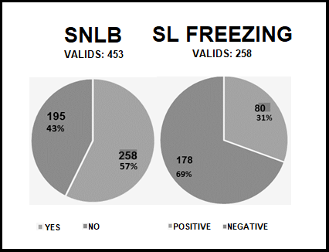
Figure 1: Sentinel lymph node biopsy (SLNB) and Sentinel Freezing.

Source: Author's research at the Cancer Institute of Ceará.

