Table 1: Statistical results of peak forces (in body weight) in eight foot regions during layup landing.

Region |  | Court | Side |  | Statistical Results
 |  |  |  |  | Side | Court | Interaction
 |  |  | Non-shooting | Shooting | P (η_{p}²) | P (η_{p}²) | P (η_{p}²)
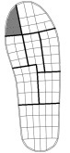 | Hallux | Wood | 0.15 (0.06) | 0.09 (0.06) | < 0.001 (0.716) | 0.022  (0.367) | 0.383  (0.064)
 |  | Asphalt | 0.15 (0.06) | 0.08 (0.05)
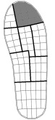 | Lesser toes | Wood | 0.24 (0.09) | 0.30 (0.09) | 0.008  (0.461) | 0.007  (0.466) | 0.799  (0.006)
 |  | Asphalt | 0.22 (0.09) | 0.28 (0.08)
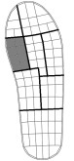 | Medial forefoot | Wood | 0.27 (0.06) | 0.22 (0.07) | 0.011  (0.431) | 0.142  (0.171) | 0.036  (0.317)
 |  | Asphalt | 0.28 (0.05) | 0.18 (0.07)
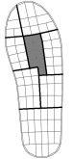 | Central forefoot | Wood | 0.39 (0.07) | 0.41 (0.08) | 0.214  (0.126) | 0.083  (0.230) | 0.793  (0.006)
 |  | Asphalt | 0.41 (0.08) | 0.43 (0.10)
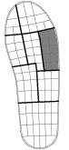 | Lateral forefoot | Wood | 0.25 (0.08) | 0.28 (0.08) | 0.351  (0.073) | 0.200  (0.133) | 0.079  (0.235)
 |  | Asphalt | 0.27 (0.10) | 0.28 (0.08)
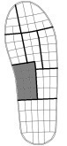 | Medial arch | Wood | 0.15 (0.11) | 0.21 (0.12) | 0.049  (0.286) | 0.347  (0.074) | 0.128  (0.182)
 |  | Asphalt | 0.17 (0.09) | 0.22 (0.11)
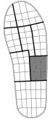 | Lateral arch | Wood | 0.22 (0.11) | 0.30 (0.12) | 0.058  (0.268) | 0.095  (0.215) | 0.103  (0.206)
 |  | Asphalt | 0.26 (0.09) | 0.31 (0.11)
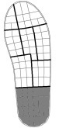 | Heel | Wood | 0.29 (0.24) | 0.65 (0.35) | 0.003  (0.543) | 0.718  (0.011) | 0.653  (0.017)
 |  | Asphalt | 0.33 (0.19) | 0.64 (0.27)
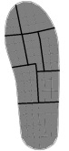 | Total | Wood | 1.71 (0.31) | 2.06 (0.51) | 0.055  (0.274) | 0.376  (0.066) | 0.330  (0.079)
 |  | Asphalt | 1.81 (0.26) | 2.07 (0.63)

Note: Data are expressed in mean (SD). The shooting side was defined as the foot on the same side of the shooting arm (right for all participants). Significant P-values from repeated measures ANOVA (P < 0.05) are shown in bold. Effect size (η_{p}²) values of 0.01, 0.09 and 0.25 were interpreted as small, medium and large effects, respectively.

