Table 3: Statistical results of peak forces (in body weight) in eight foot regions during sprint acceleration step.

Region |  | Surface | Peak Force | P-value | Effect size (r)
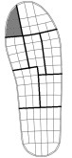 | Hallux | Wood | 0.13 (0.07) | 0.048 | -0.39
 |  | Asphalt | 0.12 (0.07)
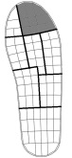 | Lesser toes | Wood | 0.34 (0.10) | 0.140 | -0.29
 |  | Asphalt | 0.30 (0.06)
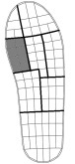 | Medial forefoot | Wood | 0.36 (0.12) | 0.010 | -0.50
 |  | Asphalt | 0.34 (0.10)
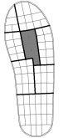 | Central forefoot | Wood | 0.57 (0.12) | 0.387 | -0.17
 |  | Asphalt | 0.56 (0.13)
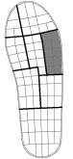 | Lateral forefoot | Wood | 0.27 (0.10) | 0.350 | -0.18
 |  | Asphalt | 0.25 (0.11)
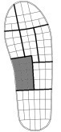 | Medial arch | Wood | 0.04 (0.04) | 0.573 | -0.11
 |  | Asphalt | 0.03 (0.04)
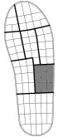 | Lateral arch | Wood | 0.10 (0.08) | 0.289 | -0.21
 |  | Asphalt | 0.08 (0.07)
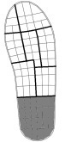 | Heel | Wood | 0.18 (0.26) | 0.721 | -0.07
 |  | Asphalt | 0.14 (0.28)
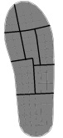 | Total | Wood | 1.62 (0.26) | 0.011 | -0.50
 |  | Asphalt | 1.53 (0.28)

Note: Data are expressed in mean (SD). Significant P-values from Wilcoxon signed-rank tests (P < 0.05) are shown in bold. Effect sizes were interpreted as: small 0.1 ≤ |r| ≤ 29, medium 0.3 ≤ |r| ≤ 0.49, large |r| ≥ 0.5.

