Table 3: Phytochemical source and mode of action.

Name of Phytochemical | Mode of Action | Structure | Source
Apigenin | Apigenin inhibited EV-A71 infection by suppressing viral internal ribosome entry site (IRES) activity | 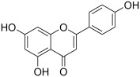 | Fruit and Vegetable parsley, Celery, Celeriac and Chamomile tea
Saikosaponins (A) | Early stage of HCoV-22E9 infection, Including viral attachment and Penetration | 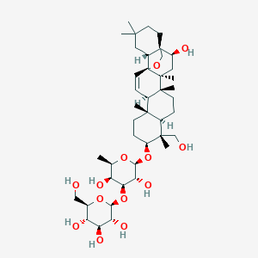 | Triterpeneglycosides  Radix Bupleuri medicinal plant
Isatisindigotica | SARS-CoV 3CL Protease inhibitor | 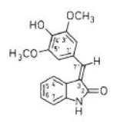 | Phenolic compound  Woad dyer's woad or Glastum
Amentoflavone | SARS-CoV 3CL Protease inhibitor | 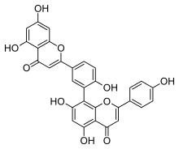 | Torreya nucifera japanease nutmag
Glycyrrhizaglabra | Inhibition of viral replication, Modulation of membrane fluidity | 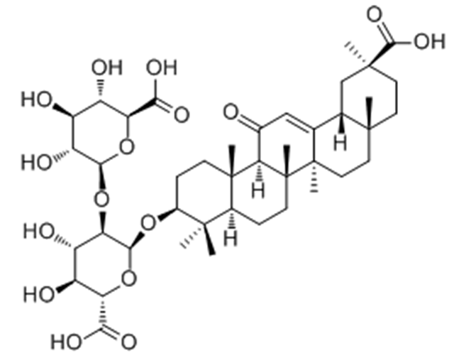 | Licorices
Vitextrifolia | Reduction |  | –
Quercetin | Reduced RNA and Protein synthesis and Antioxident activity | 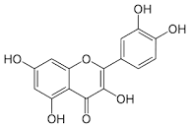 | Red (grape) wines, Leaves of radish (Raphanus raphanistrum subsp. sativus) and Fennel (Foeniculum vulgare), Seeds of pepper (Capsicum annuum)
Kaempferol | Inhibit 3a ion channel of coronavirus | 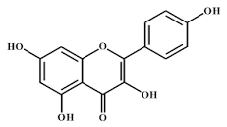 | Raspberry (Rubusidaeus), Capers (Capparisspinosa), Brussels sprout (Brassica oleracea), Black bean (Phaseolus vulgaris) and Fruit of grapes
Curcumin | By interference of viral replication machinery or Suppression of cellular signaling pathways essential for viral replication | 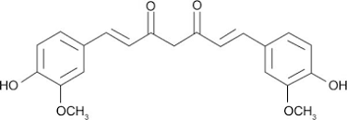 | Turmeric Indian spice

