Silver Nanoparticles Impregnated Nanocollagen as scaffold for Soft Tissue Repair- Synthesis, Characterization, and In-vitro Investigation
V. Subha¹, S.Kirubanandan¹, R. Ilangovan*¹, S. Renganathan²
1. National Centre for Nanoscience and Nanotechnology, University of Madras, Chennai -600025, India.
2. Centre for Biotechnology, Anna University, Chennai-60025. India.
* Corresponding Author: ksh1005@gmail.com/ mannargudisubha@gmail.com
Supplementary Information
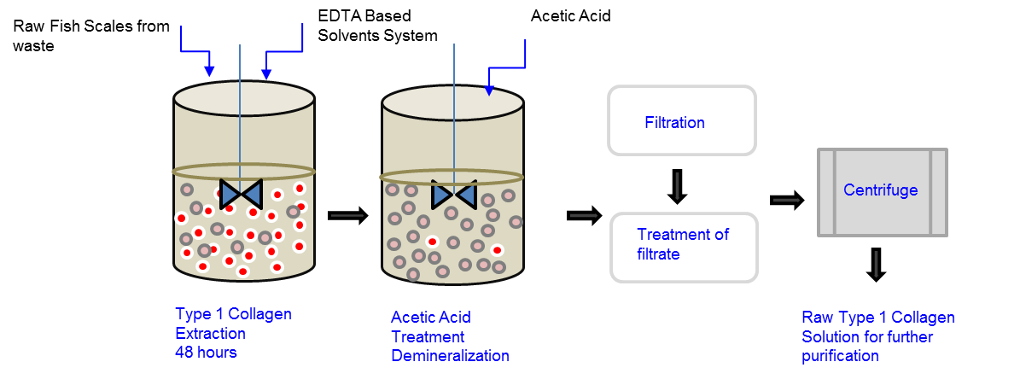

Figure S1 Extraction of Type 1 Collagen from Fish Scales

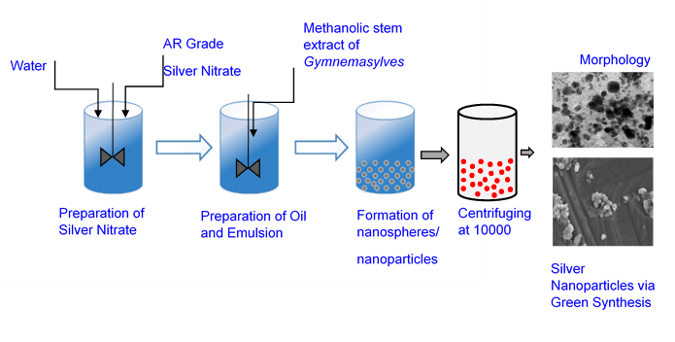
Figure S2 Green synthesis of Silver nanoparticles

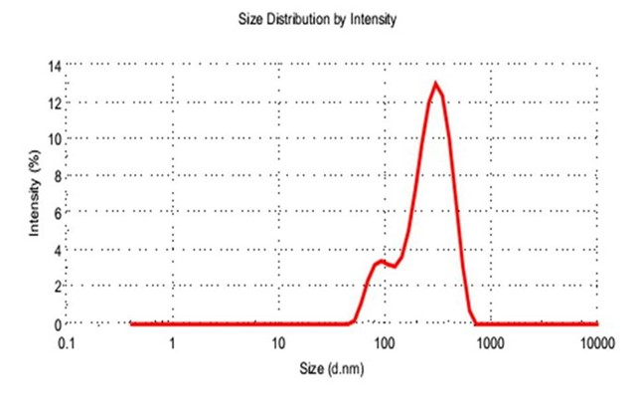
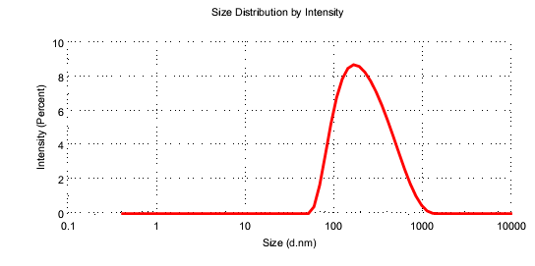
Figure S3 DLS investigation of Silver Nanoparticles
The average size of the collagen mixed up silver nanoparticles, size distribution, and polydispersity index (PDI) of the collagen assisted silver nanoparticles were determined by particle size analyser. It shows the average particle diameter is 274 nm and Polydispersity index is 0.360. The average particle size and PDI revealed that the derived collagen converted into monodispersed. The collagen size were started from 80 nm and ended with 900 μm size. A small peak one found at 91 nm and another deep peak found at 294 nm.

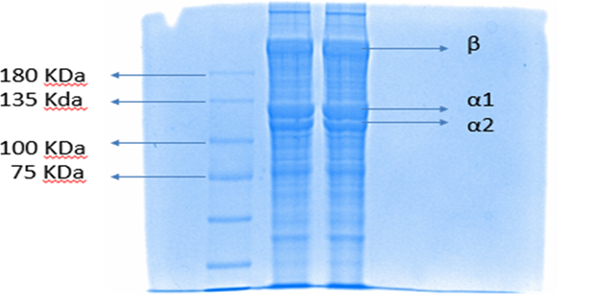
Figure S4 – SDS PAGE of Type 1 Collagen extracted from fish scales.

Molecular weight of β chain was around 200 kDa and α1, α2 chains have the molecular weight near 116 kDa. Similar pattern of results were obtained for the SDS PAGE of collagen extracted from scales of Catla catla. Fig S4 clearly shows that collagen had been extracted from the fish scales of Catla catla.

Table 1 FTIR wavelengths of collagen and silver nanoparticles.

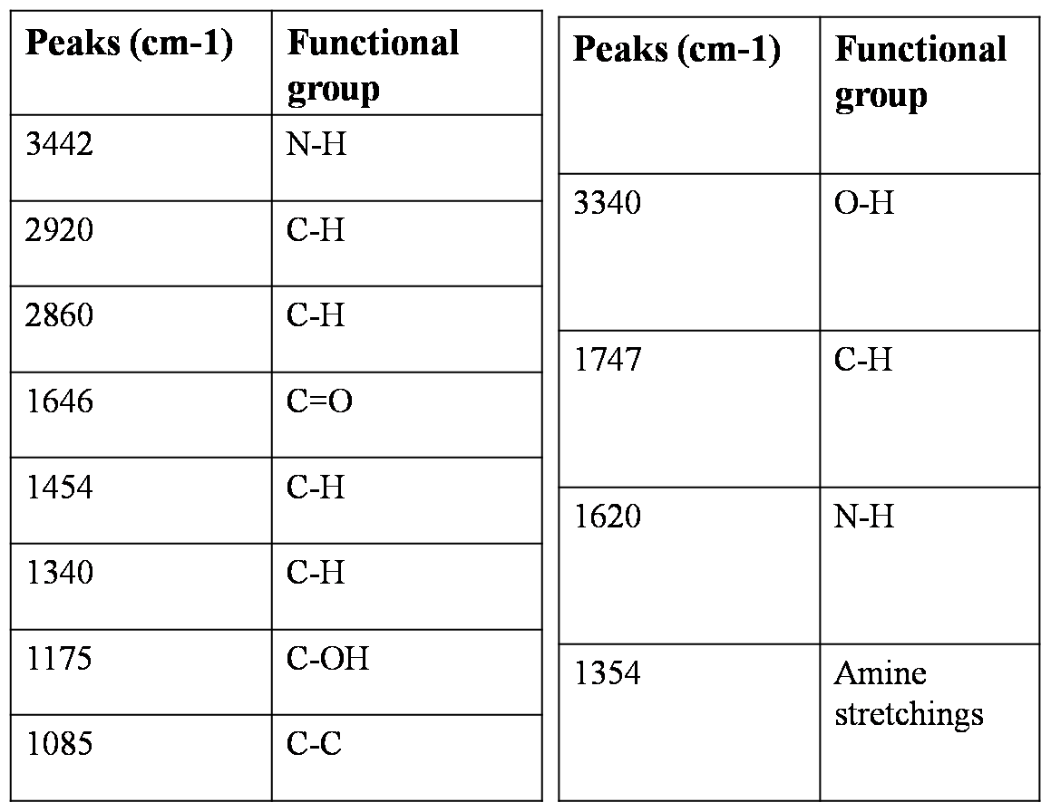

SEM Micrographs of Type 1 Collagen Fibres
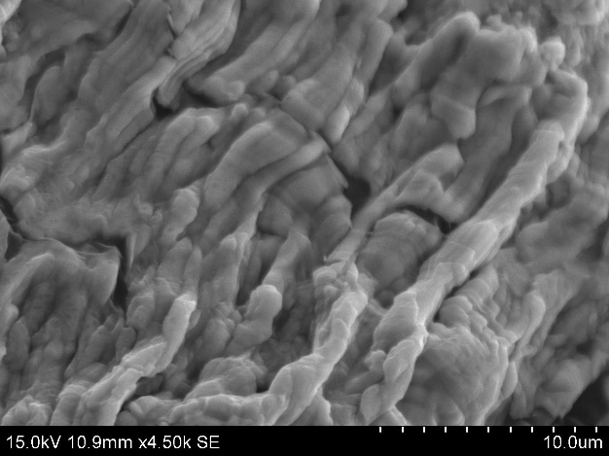 | 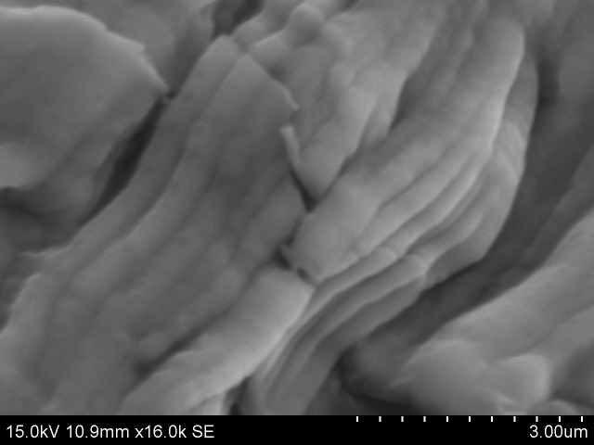
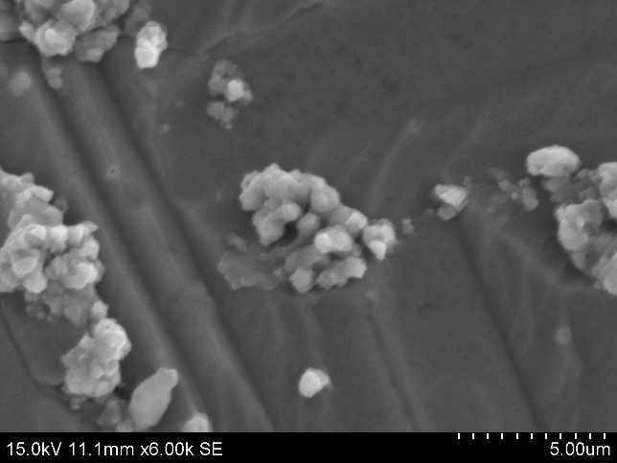 | 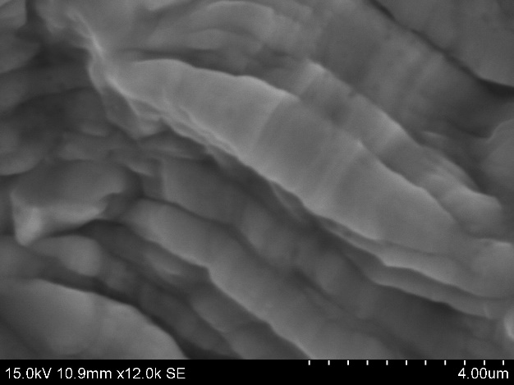
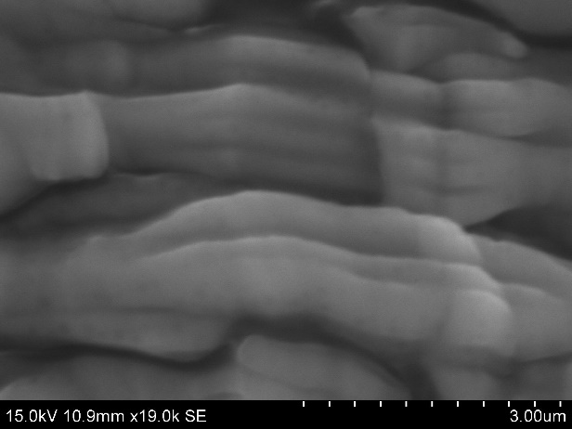

Figure S5 – Collagen Fibres from Fish Scales.

Figure S6: Green synthesized silver nanoparticles with various magnification (A and B) , Nanocollagen mixed silver nanoparticles (c)

Figure S7. Silver nanoparticles associated with collagen scaffold.

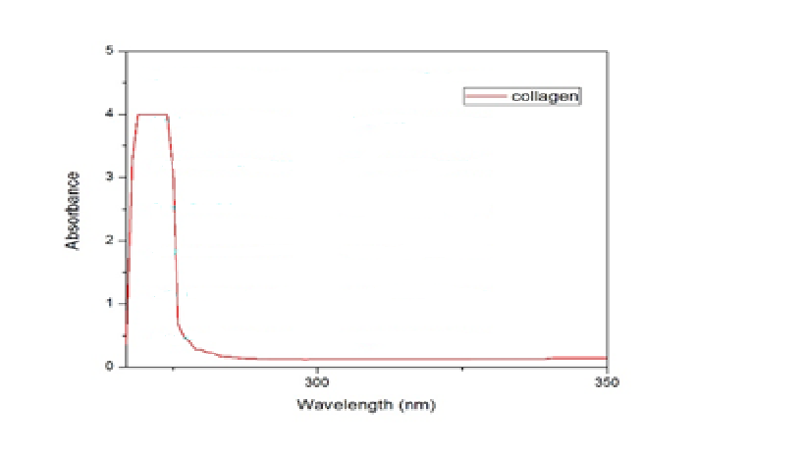
Figure S8 (a) UV spectrum of Type 1 Collagen

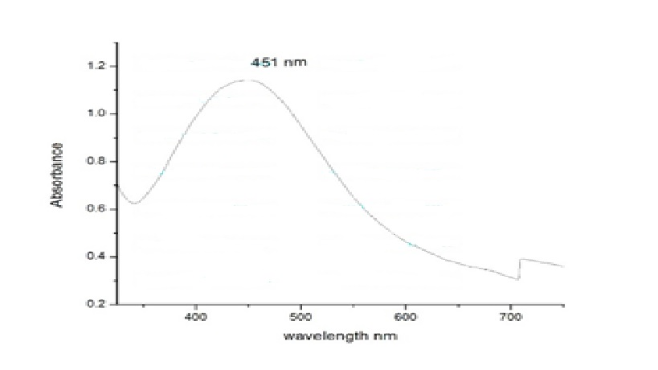
Figure S8 (b) –UV –Visble spectrum of Silver nanoparticles

