Table 2: Capturing agents that have been used to capture mercury (II) ions.
Name | Structures | References
Terphenyl-based reversible receptor with Rhodamine | 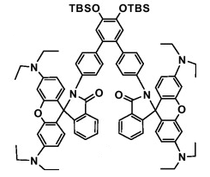 | [83]
Rhodamine-based molecular probe | 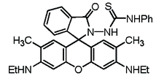 | [84]
Rhodamine-based using the spirolactam ring opening | 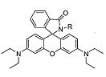 | [85]
Rhodamine B with ferrocene substituent | 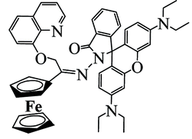 | [86]
Calix[4]arene-based receptor | 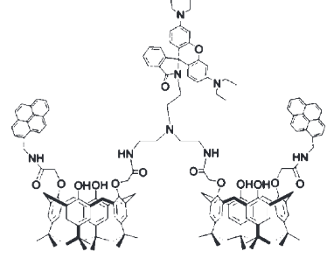 | [87]
Thioether + aniline-derived ligand framework linked to a fluorescein platform | 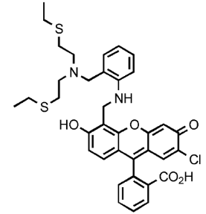 | [88]
Mercuryfluor-1 (flourescent probe) | 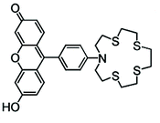 | [89]
N,N’-dibenzyl-1,4,10,13-tetraraoxa-7,16-diazacyclo-octadecane | 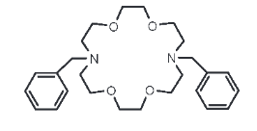 | [90]
Terphenyl-based reversible receptor with pyrene and quinoline as the fluorophores | 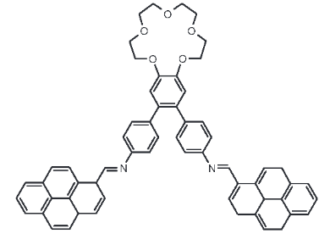 | [91]

